**3 Exercises (Due Friday of next week)**

1. Visit http://onlinestatbook.com/stat_sim/sampling_dist/ and play with this app as

described below. This is meant to help you better understand how sampling distributions

work.

(a) Start with the normal distribution that is represented on the initial screen as your

“parent population”. Select “Mean” in the third plot, “Variance” in the fourth

plot, and “N=5” for both. Run 10,000 samples through this simulation. Take a

screenshot of the results showing all four plots, including the statistics on the left

and the settings on the right. Present it as your response. No comment needed

yet.

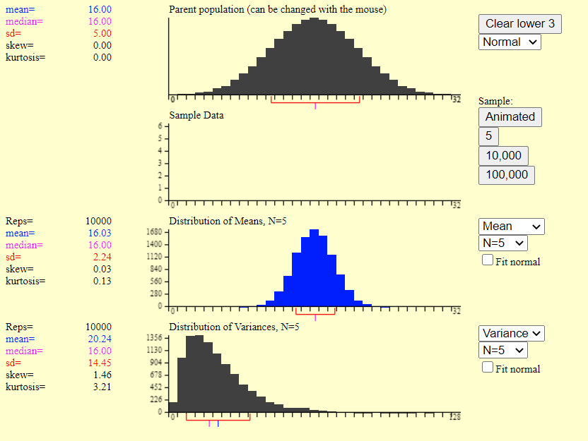

(b) Clear everything and repeat with “N=25” in both places.

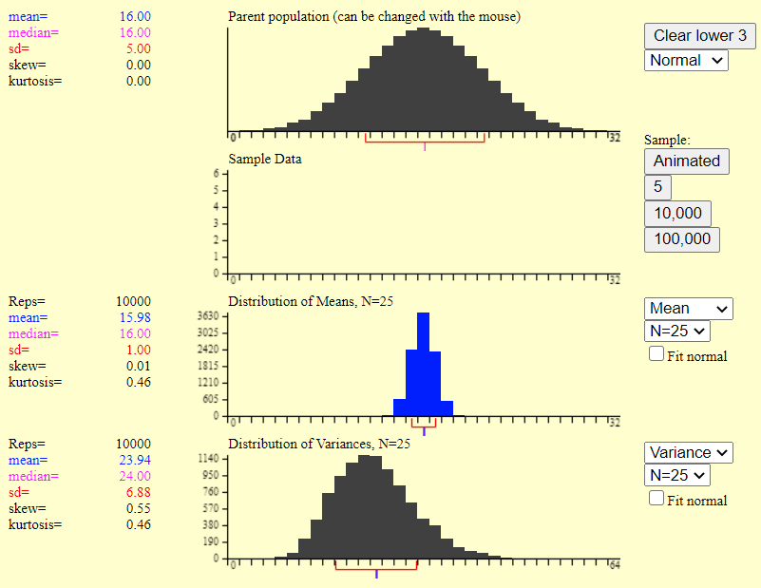

(c) Clear everything and repeat with “Skewed” in the first plot and “N=5” in the

third and fourth.

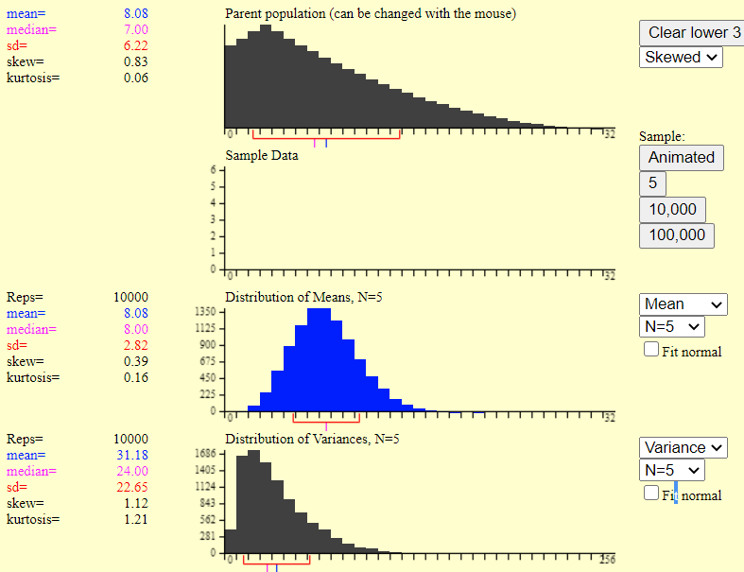

(d) Clear everything and repeat with “Skewed” in the first plot and “N=25” in the

third and fourth.

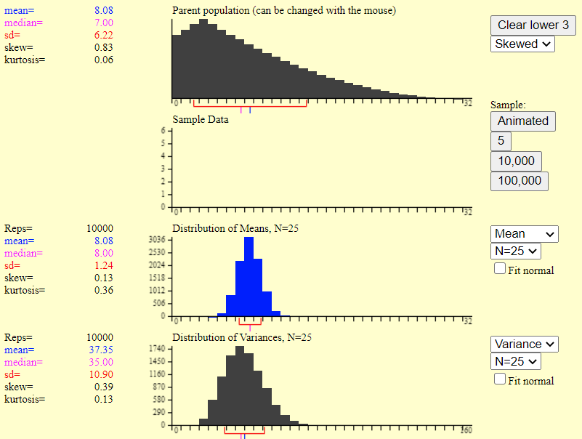

(e) Comment on the following, explaining what evidence these plots provide to support

your answers. Please note that the scales on the X-axis sometimes change,

so factor this into your explanations when necessary. You shouldn’t need more

than a sentence, or *maybe* two for each. If you say too much, you are missing the

big points and will be penalized.

i. Do different statistics computed on the same samples have to have the same

sampling distribution? No they don’t. (a) is the evidence.

ii. What effects does increasing sample size have on the sampling distributions

of statistics? Increasing sample size makes sampling distribution get close to normal distribution. (a) and (b) are evidence.

iii. What effects does changing the parent distribution (the distribution from

which data are sampled) from normal to skewed have on the sampling distributions

of statistics? It doesn’t not affect seriously. (b) and (d) are evidence.